Fundraising for Cancer Connect NI via JustGiving

- Go to the JustGiving website https://www.justgiving.com/start-fundraising

- Select the “raise money for a charity” option.

- Sign up to JustGiving using your email address, create a password for your account and complete your profile with your address details.

- Search for our details and select CCNI as your chosen charity. This is how our profile looks.

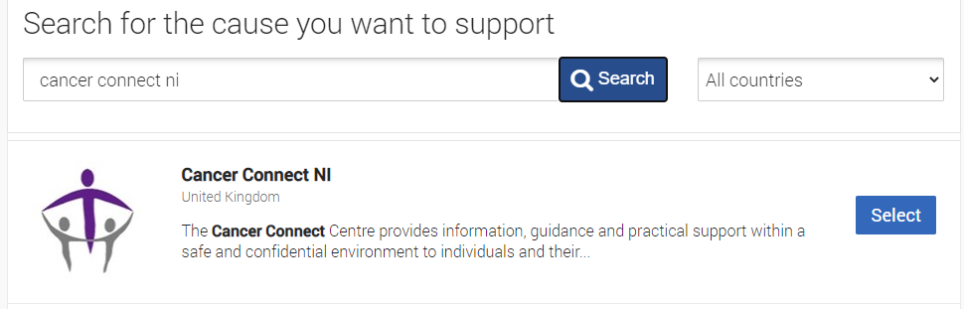

- Select what it is you are doing! For example, a charity mountain climb, celebrating a birthday or asking for donations in memory of a loved one. You can also simply select “doing your own thing” and get creative with how to promote your fundraiser!

- Finally, complete the online form you are directed to with additional details about your fundraiser and agree/confirm your understanding of JustGiving’s privacy policies and terms of service. All money raised will be paid directly to Cancer Connect NI and your supporters can use a variety of payment methods to donate, making things as simple as possible.

- That’s it – you’re good to go!

You can share your page on all social media platforms, Whatsapp and via email to raise awareness of your efforts.

Follow this link for ten top tips to help make your fundraiser a success!
https://www.justgiving.com/fundraising/tips/top-10-fundraising-tips

