Fundraising for Cancer Connect NI via Facebook

- Login to Facebook and Click on Fundraisers in the left menu of your News Feed. You may need to click See More.

- Click on the + Raise Money option and select for “charity”. Search for and select Cancer Connect NI. Our profile will look like this!
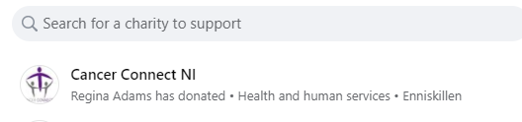
- Fill in the fundraiser details, select a cover photo and click on “create”.

You can add details like what it is you are doing! For example, a charity mountain climb, celebrating a birthday or asking for donations in memory of a loved one.

That’s it – you’re good to go!

Share with your friends on Facebook and promote your efforts by giving regular updates on your progress. All money raised will be paid directly to Cancer Connect NI and your supporters can use a variety of payment methods to donate, making things as simple as possibe.

